PART A
CHAPTER 1
DHRITVAN
COMPANY PROFILE
Company Name: DHRITVAN

Fig 1.1 Company Logo
DHRITVAN is SJCIT’s Satellite Ground Station which has been racing with the leading satellite Ground stations across the world to produce quality output in the form of weather images, telemetry data, denoising algorithms and exploring different areas of space science. The students working here would get an amazing experience to brainstorm their ideas and convert them into a real-time working environment. Figure 1.1 show the Company Logo of DHRITVAN SPACE LAB
1.2 ABOUT THE COMPANY
DHRITVAN is one of the Amateur Satellite Ground Station presents across the country and is the first and the only SATELLITE GROUND STATION in chuckwalla district, Karnataka. It was established on 27-08-2022 by the Department of Electronics and Communication Engineering at SJC Institute of Technology, Chickballapura-562101.DHRITVAN has been achieving significant results by experimenting various domains in the field of space science and satellite study. The first project taken up by DHRITVAN was to receive satellite signal from open-source weather satellite called as NATIONAL OCEANOGRAPHIC ATMOSPHERIC ADMINISTRATION (NOAA) by NASA. Emerging successful with this project DHRITVAN has a strong database of the weather images captured from NOAA satellites on daily basis. As of December 2022, DHRITVAN stands with more than 200 successful times of signal captured from and over 1000 processed weather images. The next challenge to be addressed was to capture signal from a Russian satellite called as METEOR-M2 which emits signal directly in the digital form. In parallel with signal reception from satellites using omnidirectional antenna DHRITVAN started to work with the antenna design and construction to make it as indigenously constructed satellite ground station. Antenna such as V-dipole, Turnstile, Quadrivial Helix, etc., are lined up for construction processes. Projects related to antenna design and construction has been proposed as the internship projects for student interns interested to work at DHRITVAN. Some of the future plans at DHRITVAN includes converting it into a transceiving station, development and commercialization of different types of antennae for varied application, design of components such as Low-Noise Amplifiers, noise removal filters, Software Defined Ratios, etc. Since its establishment, DHRIVAN has been making noteworthy records and achievements which has been highly appreciated by the college management, tech – circle and also from the professionals working at the Indian Space Research Organization. The highly enthusiastic team working at DHRITVAN has been working tirelessly in-order to make DHRITVAN commonly called as SPACE LAB a huge success.
DHRITVAN can be reached out through mail at dhritvan27082022@gmail.com and on social media as @dhritvan_sjcit (Instagram and Twitter). Its registered address in opp. To CN Lab, 1st floor, Academic block, SJC Institute of Technology, Chickballapura-562101.
1.3 COMPANY’S VISION AND MISSION
VISION:
- To discover, augment and understand space science for the Nation’s growth and the benefit of mankind.
MISSION:
- Developing pertinent engineering professionals to maneuver in the area of space science, research and exploration.
- Promoting emerging technologies in space science acumen to venture into innovation research activities.
- Manifest students to aeronautics, planetary exploration and emerging frontiers in related domains enabling solid and steady establishments.
- Encourage lifelong learning and experimentation among the student and faculty irrespective of the domain.

CHAPTER 2
PRELUDE
2.1 Image Processing
Image Processing of various steps to perform the different operations on image to get the enhanced or required output. Image processing is growing technology where we are using it in different ways. Recently ISRO scientists used the image processing software (IGIS) to analyse the satellite. This software can be used to scan, process and study the images and spatial data relayed by the space agency's communication and remote-sensing satellites in orbits.
IGIS – Infrastructure Geographic Information System
Steps of Image processing is as follows:
Classification
Feature
Extraction
Segmentation
Pre-Processing

Pre-processing
In this process we perform the all-mathematical operations on the image pixels. Every image consists of finite number of pixels in it. Mainly Image pre-processing methods are classified into four categories according to the size of the pixel neighbourhood that is used for the calculation of a new pixel brightness. Categories like pixel brightness transformations, geometric transformations, preprocessing methods that use a local neighbourhood of the processed pixel and lastly characterizes image restoration that requires knowledge about the entire image.
Segmentation
The goal of segmentation is to simplify and/or change the representation of an image into something that is more meaningful and easier to analyse Image segmentation is typically used to locate objects and boundaries (lines, curves, etc.) in images. Segmentation can be done based upon the Pixels based non-pixel based.
1.Pixel based segmentation
Pixel segmentation is the process of the highlight the pixels in an image that is used for the features that we have perform and the Region-based segmentation is the example of pixel-based segmentation where the Region-based segmentation is also tells us about the pixels in an image.
2.Non-pixel based segmentation
Non pixel segmentation is the process of highlight the remaining characteristics of the image except the pixels of the image like threshold-based, edge-based, cluster-based, artificial neural network-based and many more.

Basically, an image is classified into the colour and black white images. In the colour images we had gone through different types of planes such as rgb,hsv,YCbCr.
RGB
In rgb we have three different types of planes such as red, green and blue. Where each colour image is prepared by these three planes with respect to the computers. Considering the matrix A has dimensions 480 x 640 x 3. The third dimension are three 480 x 640 planes and colour channels is as follows:
red = A(:,:,1)
green = A(:,:,2)
blue = A(:,:,3)
As there is a byte for each pixel location, the red can vary between 0 (zero) which means "no red" and 255 which means "full red". Likewise, the green and blue. So, an image where all the pixels are

Red=255, Green=0, Blue=0 will look very bright red
Red=0, Green=255, Blue=0 will look very green
HSV
In hsv is also a colour scale where it consists of the Hue, Saturation and Value and it is used to try to capture the components of the way humans perceive colour.
Hue value vary from 0 to 1 that corresponds to the colour’s position on a colour wheel. As hue increases from 0 to 1, the colour transitions from red to orange, yellow, green, cyan, blue, magenta, and finally back to red.
Saturation is the amount of hue or departure from neutral. 0 indicates a neutral shade, whereas 1 indicates maximum saturation.
Value tells us about the maximum value among the red, green, and blue components of a specific colour.
YCrCb
In YCrCb, which performed on the rgb plane, we can separate the separate the luminance from chrominance more effectively compare to rgb colour space and YCrCb translates the colours by brightness and Chroma. Cr is the red minus luma and Cb is the blue minus luma where Y is the luma or luminance. Considering the output of an image in ycbcr then
y = ycbcr(:,:,1)
cb = ycbcr(:,:,2)
cr = ycbcr(:,:,3)

CONVERSIONS FROM PLANE TO ANOTHER PLANE IN OCTAVE
- rgb2hsv
This command is used in performing of conversion rgb to hsv.
- rgb2ycbcr
This command is used in performing of conversion rgb to ycbcr.
Coming to black white images we have two types of images that are gray scale images and ground truth.
GRAY SCALE
In this gray scale image consists of different shades of black and white and we can differentiate them by using the thresholds. For each pixel in image consists of the value and it is known as the threshold. For pure white it will be 255 and pure black it will be 0 and remaining pixels have their thresholds depend upon the region in the image if pixel colour is nearer to white then threshold will be nearer to 255 and if pixel colour is nearer to the black then its threshold is nearer to 0.

- rgb2gray
This command is used in performing of conversion rgb to gray.
GROUND TRUTH
In ground truth we have only the pure white and pure black and their thresholds is for the pure white it is 1 and for pure black it is 0.
We use the ground truth only for the comparison if the pixel-thresholds.
FEATURE EXTRACTION
In the context of feature extraction, features can be categorized into low-level features and high-level features. These two categories represent different levels of abstraction and complexity in the information they capture from the data.
1. Low-Level Features
Low-level features, also known as primitive features or basic features, capture simple and fundamental characteristics of the data. They are often derived directly from the data without much processing. These features tend to be more elemental and may not carry semantic or contextual information.
Low-level features are the building blocks for higher-level feature extraction and analysis.
2. High-Level Features
High-level features, also known as semantic features or abstract features, are derived from low-level features through additional processing, transformation, or context-ware analysis. They capture more complex and meaningful information, related to specific tasks or interpretations. High-level features tend to be more informative and may carry contextual content. High-level features are often used for tasks that require a deeper understanding of the data, such as classification, recognition, and decision-making.
Both types of features to leverage both the basic properties of the data and the more abstract information they contain like Pixel intensity values, colour values, gradients, texture patterns, and basic shape properties like edges and corners.

CHAPTER 3
IMAGE PROCESSING
3.1 Imperatives
Initially we had performed on operations on the p44 and ground truth is the image that is used for comparison. Octave is the open-source tool that is used for the image processing. Here the object is the balloons and we have to perform on the balloons.
BASIC COMMANDS IN OCTAVE
- imread
It is used to read the data from a file.
- imshow
It is used to show the desired output. We use montage for the combining of the two images and displayed as the output.
- imresize
It is used to resize the data from an input.
3.2 Calculations of the image in octave
True positive [TP]
It is an outcome where the model correctly predicts the positive class.
True negative [TN]
It is an outcome where the model correctly predicts the negative class.
False positive [FP]
It is an outcome where the model incorrectly predicts the positive class.
False negative [FN]
It is an outcome where the model incorrectly predicts the negative class.
True positivity rate or sensitivity [TPR]
$TPR=\frac{TP}{TP+FN}$
True negative rate or specificity [TNR]
$TNR=\frac{TN}{FP+TN}$
Accuracy [Acc]
$Acc=\frac{TP+TN}{TP+FP+TN+FN}$
3.3 Morphological operations
- STRUCTURING ELEMENT: Structuring elements are fundamental in morphological image processing, where they define the neighbourhood around a pixel for operations like erosion and dilation. In octave Strel (shape, parameters) is a function used to create structuring element, where shape specifies the type of structuring element like disk, square, line and parameters define its size and orientation.
- EROSION: Erosion is used to shrink or erode the boundaries of white [foreground] regions in a binary image. It is used to remove small white regions, disconnect objects that are too close, and reduce the size of objects in the binary image.
Syntax: imerode(BW, SE)
- DILATION: Dilation is used to expand or dilate the boundaries of white regions in a binary image. Dilation can be used to close small gaps between objects, make objects thicker, and generally expand the size of objects in the binary image.
Syntax: imdilate(BW, SE)
- OPEN: Opening is a sequence of erosion followed by a dilation operation. Opening is effective at removing small noise or fine details while preserving the overall shape and size of larger objects in the binary image.
Syntax: imopen(BW, SE)
- CLOSE: Closing is a sequence of a dilation followed by an erosion operation. Closing can fill small holes or gaps in objects while retaining the general shape and size of objects in the binary image.
Syntax: imclose(BW, SE)

3.4 Binary image connected component
The input parameters are binary image and connectivity criteria (typically 4-connectivity or 8- connectivity). The function returns a structure CC that contains information about the connected components found in the binary image.
Syntax: CC = bwconncomp(bw,conn);
This structure includes NumObject, PixelIdxList, ImageSize, Connectivity. We can further analyse or manipulate these components. For example, you can extract properties like the area, centroid, bounding box, and more for each object using functions like regionprops().

3.5 Confusion matrix:

A confusion matrix is a tabular representation used in classification tasks to assess the performance of a machine learning model, particularly in binary classification. It summarizes the model's predictions compared to the actual outcomes. The confusion matrix is organized as TRUE POSITIVE, FALSE POSITIVE, TRUE NEGATIVE, FALSE NEGATIVE.
The following commands are used to work with confusion matrix in MATLAB.
Con_mat = confusionmat(trueLabels, predictedLabels);
This function computes the confusion matrix given the actual labels and predicted labels.
Con_chart = confusionchart(trueLabels, predictedLabels);
This function creates a visual representation of the confusion matrix with additional visual aids, making it easier to interpret.
Syntax: stats = regionprops(BW, properties)
Its primary purpose is to extract properties and measurements of connected components in a binary image. The input parameters are binary image and properties. Available properties include Area, Bounding Box, Centroid, Perimeter. Function returns a structure array containing the properties for each connected component in the binary image.
STATS:

The region props function return’s structure called stats which hold properties of each connected component. [stats. Area] holds the area of connected component. [stats. Bounding Box] holds four elements. They are x-coordinate of the upper-left corner, y-coordinate of the upper-left corner, width of the bounding box and height of the bounding box. [stats. Centroid] is an array of two elements which holds x-coordinate and y-coordinate of centroid.

CHAPTER 4
PROBLEM SOLVING
4.1 Problem statement-1:
Classify the foreground and background regions in an image through implementation of a singular thresholding technique.
Algorithm:
Step1: Load the image and the ground truth which we want to perform the single threshold.
Step2: Convert the image to grayscale image.
Step3: Create an array thresh containing values from 1 to 254. Initialize arrays TP, FP, TN, FN, Accuracy, TPrate, FPrate.
Step4: Perform the looping operation on over each threshold value over the length of thresh.
Step5: For each iteration perform the following three operations.
- Create a binary image by the threshold image.
- Then calculate TP, FP, TN, FN for the binary image.
- At last, calculate Accuracy, TPrate and FPrate based on the TP, FP, TN, FN.
Step6: Find best value as the maximum value in the Accuracy array. Find best image as the index of the threshold with the maximum accuracy.
Step7: Display the best threshold image and ground truth.
Step8: Plot the ROC curve by plotting the FPrate against TPrate.
Results:
Figure 4.1.1: Actual image and ground truth.
Figure 4.1.2: Best threshold image.
Figure 4.1.3: ROC curve for single threshold.

Observation:
Here we discussed about accuracy for single threshold and we can observe that the loss of information in the single threshold. To overcome this loss of information we use two thresholds.

4.2 Problem statement-2:
Classify foreground and background regions within an image through the implementation of a double thresholding technique.
Algorithm:
Step1: Load required the image and its ground truth.
Step2: Extract the individual colour planes (red, green, blue) from the RGB image to find out
the which two planes is used for the next process.
Step3: Define two threshold ranges, thresh1 and thresh2, typically ranging from 1 to 254.

Step4: Inside a nested for loop of ranges thresh1 and thresh2, create a binary image by applying double thresholding on the red and green channels.
Step5: Calculate accuracy, TPrate, FPrate by comparing the binary image with the ground truth using the user defined function and then store the results.
Step6: Determine the best accuracy by finding the maximum accuracy values in both rows and columns of the accuracy matrix. Identify the corresponding threshold values and that achieved the best accuracy.
Step7: Display the best threshold image and the ground truth image side by side in a figure. Plot the ROC curve for false alarm rate versus true detection rate.

 | Single threshold | Double threshold
Best threshold | 91 | Red=93, Green=85
Accuracy | 98.51% | 99.64%
Results:

Tab1: Best threshold and Accuracy for single and double thresholds

Figure 4.2.1: Best double threshold image and the ground truth

Figure 4.2.2: ROC curves for two different thresholds
(Single threshold-blue and Double threshold-red)
Observation:
Here in the above the ROC curve we can see that there is loss of information but is in less amount when compared single threshold ROC curve. We regained the information by double threshold by pixels.

4.3 Problem statement-3:
Apply the morphological operations to a given binary image, to fill cavities within the regions of interest, to attain smooth borders and to eliminate noise, thereby enhancing the quality of the image.
Algorithm:
Step1: Load the required image and its ground truth to perform the morphological operations.
Step2: Make sure what type of morphological that we want to perform to obtain the best version of that image.
Step3: Now read the original image by using the path location.
Step4: Resize the original image.
Step5: Create a structural element by using the inbuilt function strel().
Step6: Now perform the morphological operation either dilation or erosion, if required perform the both operations.
Step7: Display the original image, Ground truth and the morphed image.
Step8: Call the user defined function with morphed image and ground truth as input parameters to calculate accuracy, true positive rate, and false positive rate.

Results:
Accuracy of morphed image compared to ground truth is 0.993657
Figure:4.3.1 Original image Figure:4.3.2 Morphed image

Observation:
We observe that the borders of the image are smoothened and cavities inside the regions of interest (balloons) are closed. Therefore, we got image with enhanced quality with accuracy of 0.993657 in comparison to ground truth.
4.4 Problem statement-4:
Determine the accurate and optimal thresholds for generating a binary mask for a given RGB image after converting it into its HSV equivalent.
Algorithm:
Step1: Convert the loaded RGB image to the HSV colour space and store the individual hue, saturation, and value components in h component, s component and v component.
Step2: Create two arrays thresh1 and thresh2, ranging from 0 to 1 with a step of 0.01. These will be used for thresholding hue and saturation values, respectively.
Step3: Perform a nested for loop for the ranges of thresh1, thresh2 respectively. For each combination of thresh1(i) and thresh2(j), create a binary mask based on the conditions based upon the condition.
Step4: Calculate accuracy, true positive rate, and false positive rate by comparing binary image to the ground truth image store these metrics.
Step5: Find the highest accuracy for the hue channel and for the saturation channel respectively and determine corresponding indices hue image and saturation image respectively.
Step6: Extract and display the binary mask corresponding to the best thresholds.
Step7: Display the accuracy of the mask compared to the ground truth, best thresholds for hue and saturation planes.
Result:
Figure:4.4.1 Mask obtained by HSV representation
Observation:
Accuracy of mask compared to ground truth is 0.997367 and the best threshold for hue channel is 0.2100 and the best threshold for saturation channel is 0.4800.

4.5 Problem statement-5:
For the given database of 51 images, Identify and count the number of balloons present in each image. Construct a confusion matrix that which gives the accuracy.
Algorithm:
Step1: Load the database in which contains the 51 images through its name.

Step2: Through loop load each image of the 51 images and perform the next three steps on each iteration.
Step3: Load the current image from the file and convert it to the HSV colour s and extract the hue and saturation components.
Step4: Create a binary mask based on specified hue and saturation thresholds (0.21 and 0.48). Perform morphological operations on the mask to enhance its quality.
Step5: Calculate the number of connected components (balloons) in the mask. Display the original image alongside the processed mask, showing the number of balloons detected.
Step6: Define the true classes, representing the actual number of balloons in each image. And
predicted class containing the detected number of balloons for each image.

Step7: Calculate a confusion matrix to compare the true class and predicted class then generate a confusion chart using the confusion matrix and labels.
Result:
Figure:4.5.1
Figure:4.5.2
Figure:4.5.3
In figures 4.5.1, 4.5.2 and 4.5.3 we have original image on the left side and the count is on top lastly the masked image is on right side.
Figure:4.5.4 Confusion matrix
Observation:
By this we can say that algorithm is perfectly succeeded to produce the confusion matrix based upon the true class and predicted class

PART B
CHAPTER 5
INTRODUCTION TO ANTENNA
Antenna
An antenna is a device used to transmit and receive electromagnetic signals. It is typically composed of metal elements that are designed to radiate or receive electromagnetic waves.
Antennas are used in various applications such as communication systems, radar systems, and wireless networks.
They play a crucial role in enabling the transmission and reception of signals over long distances. The design and characteristics of an antenna determine its efficiency and performance.

Different Types of Antennas
Till now we have covered the properties of antennas, and now we will discuss different types of antennas that are used for different applications.
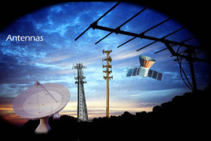
Figure 5.1: Antennas
5.2 Types of Antennas
- Log Periodic Antennas
- Wire Antennas
- Travelling Wave Antennas
- Microwave Antennas
- Reflector Antennas

Log-Periodic Antennas
A log-periodic antenna is also named a log-periodic array. It is a multi-element, directional narrow beam antenna that works on a wide range of frequencies. This antenna is made of a series of dipoles placed along the antenna axis at different space intervals of time followed by a logarithmic function of frequency. A log-periodic antenna is used in a wide range of applications where variable bandwidth is required along with antenna gain and directivity.
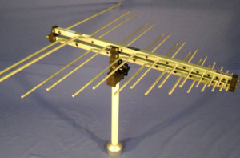
Figure5.2.1: Log Periodic Antenna

Examples of log periodic antennas are Bow-Tie Antennas and Log-Periodic Dipole Array

Wire Antennas
Wire antennas are also known as linear or curved antennas. These antennas are very simple, cheap, and are used in a wide range of applications. These antennas are further subdivided into four as explained below.
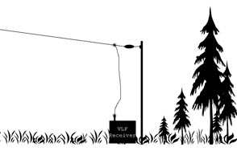
Figure 5.2.2: Wire Antennas

Examples of wire antennas are Dipole Antenna, Short-Dipole Antenna, Monopole Antenna and

Loop Antenna.

Travelling Wave Antennas
These antennas are classified into different types which are discussed below.

Helical Antennas
Helical antennas are also known as helix antennas. They have relatively simple structures with one, two, or more wires each wound to form a helix, usually backed by a ground plane or shaped reflector and driven by an appropriate feed. The most common design is a single wire backed by the ground and fed with a coaxial line.In General, the radiation properties of a helical antenna are associated with this specification: the electrical size of the structure, wherein the input impedance is more sensitive to the pitch and wire size.
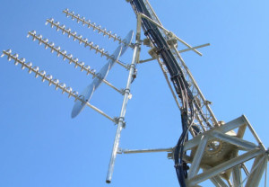
Figure 5.2.3: Helical Antenna
Helical antennas have two predominant radiation modes: the normal mode and the axial mode.
Yagi-Uda Antenna
Another antenna that makes use of passive elements is the Yagi-Uda antenna. This type of antenna is inexpensive and effective. It can be constructed with one or more reflector elements and one or more director elements.
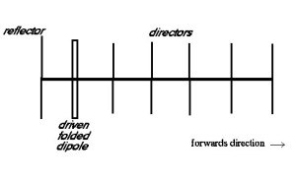
Figure 5.2.4: Yagi-Uda Antenna
Yagi antennas can be made by using an antenna with one reflector, a driven folded-dipole active element, and directors, mounted for horizontal polarization in the forward direction.

Microwave Antennas
The antennas operating at microwave frequencies are known as microwave antennas. These antennas are used in a wide range of applications.

Rectangular Microstrip Antennas
For spacecraft or aircraft applications – based on the specifications such as size, weight, cost, performance, ease of installation, etc. – low profile antennas are preferred. These antennas are known as rectangular microstrip antennas or patch antennas; they only require space for the feed line which is normally placed behind the ground plane. The major disadvantage of using these antennas is their inefficient and very narrow bandwidth, which is typically a fraction of a percent or, at the most, a few percent.
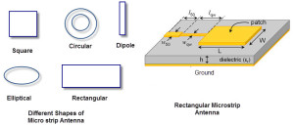
Figure 5.2.5: Rectangular Microstrip Antennas

Planar Inverted-F Antennas
A Planar Inverted-F Antenna can be considered as a type of linear Inverted F antenna (IFA) in which the wire radiating element is replaced by a plate to increase the bandwidth. The advantage of these antennas is that they can be hidden into the housing of the mobile when compared to different types of antennas like a whip, rod, or helical antennas, etc.

Reflector Antennas
These antennas are classified into two types which are discussed below.
Corner Reflector Antenna
The antenna that comprises one or more dipole elements placed in front of a corner reflector, is known as a corner-reflector antenna. The directivity of an antenna can be increased by using reflectors. In the case of a wire antenna, a conducting sheet is used behind the antenna for directing the radiation in the forward direction.
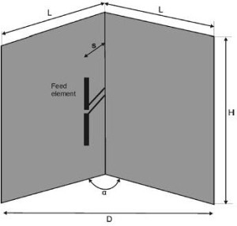
Figure 5.2.6: Corner Reflector Antenna

Parabolic-Reflector Antenna
The radiating surface of a parabolic antenna has very large dimensions compared to its wavelength. The geometrical optics, which depend upon rays and wavefronts, are used to know about certain features of these antennas. Certain important properties of these antennas can be studied by using ray optics, and of other antennas by using electromagnetic field theory.
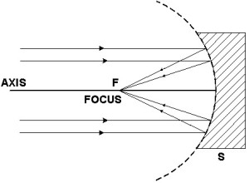
Figure 5.2.7: Parabolic Antenna
One of the useful properties of this antenna is the conversion of a diverging spherical wavefront into a parallel wavefront that produces a narrow beam of the antenna. The various types of feeds that use this parabolic reflector include horn feeds, Cartesian feeds, and dipole feeds.
ABOUT ANSYS HFSS SOFTWARE
Ansys HFSS (High-Frequency Structure Simulator) is a 3D electromagnetic simulation software for designing and simulating high-frequency electronic products such as antennas, antenna arrays, high-speed interconnects, filters, connectors, IC components and packages and printed circuit boards.
- Model and simulate a wide variety of antenna types, including linear antennas, planar antennas, and aperture antennas.
- Analyze the antenna's radiation pattern, impedance, gain, and efficiency.
- Optimize the antenna's design for specific performance requirements.
- Troubleshoot antenna design problems.
Here are some examples of how HFSS is used for antenna design:
- Aerospace engineers use HFSS to design antennas for aircraft, spacecraft, and missiles.
- Defense engineers use HFSS to design antennas for radar systems, electronic warfare systems, and communication systems.
- Telecommunications engineers use HFSS to design antennas for cellular base stations, satellite communication systems, and wireless networks.

CHAPTER-6
ANTENNA PARAMETERS
The basic communication parameters are used to the wireless communication using antennas. The wireless communication is done in the form of waves. Hence, we need to have a look at the properties of waves in the communications.
we are going through the following parameters
- Frequency
- Wavelength
- Impedance matching
- VSWR & reflected power
- Bandwidth
- Percentage bandwidth
- Radiation intensity

Frequency

According to the standard definition, “The rate of repetition of a wave over a particular period of time, is called as frequency.” Simply, frequency refers to the process of how often an event occurs. A periodic wave repeats itself after every ‘T’ second (time period). Frequency of periodic wave is nothing but the reciprocal of time period (T)Mathematically, it is written as
$$F=\frac{1}{T}$$
Where
- f is the frequency of periodic wave.
- T is the time period at which the wave repeats.

Units: The unit of frequency is Hertz, abbreviated as Hz.
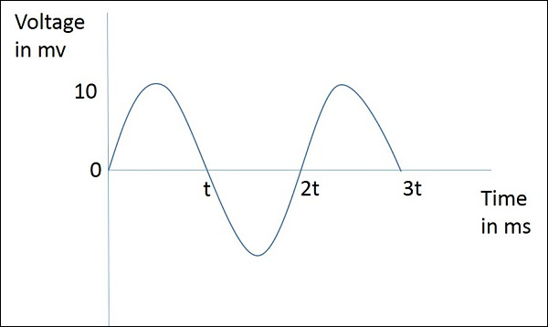
The figure given above represents a sine wave, which is plotted here for Voltage in millivolts against time in milliseconds. This wave repeats after every 2t milliseconds. So, time period T=2t milliseconds and frequency,
$f=\frac{1}{2T}$ KHz

Wavelength
According to the standard definition, “The distance between two consecutive maximum points (crests) or between two consecutive minimum points (troughs) is known as the wavelength.” Simply, the distance between two immediate positive peaks or two immediate negative peaks is nothing but the length of that wave. It can be termed as the Wavelength. The following figure shows a periodic waveform. The wavelength (λ) and amplitude are denoted in the figure. The higher the frequency, the lesser will be the wavelength and vice versa.
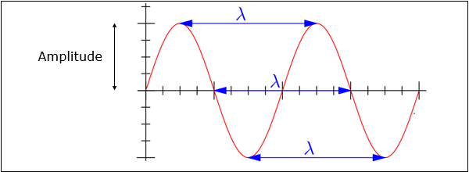
The formula for wavelength is,
$$λ=\frac{c}{f}$$
Where
- λ is the wavelength
- c is the speed of light (3∗1083∗108 meters/second)
- f is the frequency

Units: The wavelength λ is expressed in the units of length such as meters, feet or inches. The commonly used term is meters.

Impedance Matching
According to the standard definition, “The approximate value of impedance of a transmitter, when equals the approximate value of the impedance of a receiver, or vice versa, it is termed as Impedance matching.”
Impedance matching is necessary between the antenna and the circuitry. The impedance of the antenna, the transmission line, and the circuitry should match so that maximum power transfer takes place between the antenna and the receiver or the transmitter.

Units: The unit of impedance (Z) is Ohms.

VSWR & Reflected Power
According to the standard definition, “The ratio of the maximum voltage to the minimum voltage in a standing wave is known as Voltage Standing Wave Ratio.” If the impedance of the antenna, the transmission line and the circuitry do not match with each other, then the power will not be radiated effectively. Instead, some of the power is reflected back.
The key features are −
- The term, which indicates the impedance mismatch is VSWR.
- VSWR stands for Voltage Standing Wave Ratio. It is also called as SWR.
- The higher the impedance mismatch, the higher will be the value of VSWR.
- The ideal value of VSWR should be 1:1 for effective radiation.
- Reflected power is the power wasted out of the forward power. Both reflected power and VSWR indicate the same thing.

Bandwidth
According to the standard definition, “A band of frequencies in a wavelength, specified for the particular communication, is known as bandwidth.” The signal when transmitted or received, is done over a range of frequencies. This particular range of frequencies are allotted to a particular signal, so that other signals may not interfere in its transmission.
- Bandwidth is the band of frequencies between the higher and lower frequencies over which a signal is transmitted.
- The bandwidth once allotted, cannot be used by others.
- The whole spectrum is divided into bandwidths to allot to different transmitters.
The bandwidth, which we just discussed can also be called as Absolute Bandwidth.

Percentage Bandwidth
According to the standard definition, “The ratio of absolute bandwidth to the center frequency of that bandwidth can be termed as percentage bandwidth.”
The particular frequency within a frequency band, at which the signal strength is maximum, is called as resonant frequency. It is also called as center frequency (fC) of the band.
- The higher and lower frequencies are denoted as f_{H} and f_{L} respectively.
- The absolute bandwidth is given by- f_{H} - f_{L}.
- To know how wider the bandwidth is, either fractional bandwidth or percentage bandwidth has to be calculated.
The Percentage bandwidth is calculated to know how much frequency variation either a component or a system can handle. The higher the percentage bandwidth, the wider will be the bandwidth of the channel.

Radiation Intensity
“Radiation intensity is defined as the power per unit solid angle”Radiation emitted from an antenna which is more intense in a particular direction, indicates the maximum intensity of that antenna. The emission of radiation to a maximum possible extent is nothing but the radiation intensity. Radiation Intensity is obtained by multiplying the power radiated with the square of the radial distance.

Units: The unit of radiation intensity is Watts/steradian or Watts/radian².

Directivity
According to the standard definition, “The ratio of maximum radiation intensity of the subject antenna to the radiation intensity of an isotropic or reference antenna, radiating the same total power is called the directivity.”
An Antenna radiates power, but the direction in which it radiates matters much. The antenna, whose performance is being observed, is termed as subject antenna.
Its radiation intensity is focused in a particular direction, while it is transmitting or receiving. Hence, the antenna is said to have its directivity in that particular direction.
- The ratio of radiation intensity in a given direction from an antenna to the radiation intensity averaged over all directions, is termed as directivity.
- If that particular direction is not specified, then the direction in which maximum intensity is observed, can be taken as the directivity of that antenna.
- The directivity of a non-isotropic antenna is equal to the ratio of the radiation intensity in a given direction to the radiation intensity of the isotropic source.
- The radiated power is a function of the angular position and the radial distance from the circuit. Hence, it is expressed by considering both the terms θ and Ø.

Aperture Efficiency
According to the standard definition, “Aperture efficiency of an antenna, is the ratio of the effective radiating area (or effective area) to the physical area of the aperture.”
An antenna has an aperture through which the power is radiated. This radiation should be effective with minimum losses. The physical area of the aperture should also be taken into consideration, as the effectiveness of the radiation depends upon the area of the aperture, physically on the antenna.

Antenna Efficiency
According to the standard definition, “Antenna Efficiency is the ratio of the radiated power of the antenna to the input power accepted by the antenna.”
Simply, an Antenna is meant to radiate power given at its input, with minimum losses. The efficiency of an antenna explains how much an antenna is able to deliver its output effectively with minimum losses in the transmission line.
This is otherwise called as Radiation Efficiency Factor of the antenna.

Gain
According to the standard definition, “Gain of an antenna is the ratio of the radiation intensity in a given direction to the radiation intensity that would be obtained if the power accepted by the antenna were radiated isotropically.”
Simply, gain of an antenna takes the directivity of antenna into account along with its effective performance. If the power accepted by the antenna was radiated isotropically (that means in all directions), then the radiation intensity we get can be taken as a referential.
- The term antenna gain describes how much power is transmitted in the direction of peak radiation to that of an isotropic source.
- Gain is usually measured in dB.
- Unlike directivity, antenna gain takes the losses that occur also into account and hence focuses on the efficiency.

Units: The unit of gain is decibels or simply dB.

CHAPTER 3
DESIGNS OF ANTENNA
3.1 Task 1:
Creating a design of Microstrip Rectangular Patch Antenna in HFSS for operating frequency(f), display all the resulting parameters.
Design Parameters | Description | Obtained values from Calculation(mm) | Optimized values for Performance(mm)
Wp | Width of patch | 3.386 | 3.62
Lp | Length of patch | 2.551 | 2.45
Wg | Width of substrate and ground plane | 5.49 | 6
Lg | Length of substrate and ground plane | 4.65 | 6
Wf | Width of feed line | 0.46 | 0.46
Lf | Length of feed line | 1.57 | 1.57

TABLE 3.1.1: Obtained and optimized values of design parameters
The basic microstrip patch antenna has a patch, substrate, ground plane, and feed line and these portion’s geometrical designs are calculated by utilizing the Maxwell equation. These equations are introduced by maxwell who combined the theory of magnetism and electricity. For the design, RT-Duroid 5880 material is used as substrate which has the dielectric constant value "r is 2.2 and the thickness of the substrate h is 0.5 mm. Every antenna requires the resonance frequency for the process and the proposed work is utilizing 35 GHz as the resonance frequency which is more preferable for the 5G wireless communication. The design parameters of the microstrip patch antenna are calculated by utilizing the following equations.
Steps:
- Firstly, launch HFSS software and create a new project.
- Draw the rectangular patch antenna with the desired dimensions.
- Add a ground plane beneath the patch and ensure it extends beyond the patch edges.
- Define the substrate dimensions and place a patch on the substrate.
- Specify the substrate material properties such as relative permittivity(ℇr).
- Specify the substrate thickness(h) and the height of the substrate above the ground plane.
- Add a Microstrip line as a feeding structure to excite the patch, and define the width and position of the feed line.
- Set up the simulation settings, including the frequency range, type of analysis, and desired results.
- Run the simulation and extract the parameters like resonant frequency, gain, bandwidth, and so on.

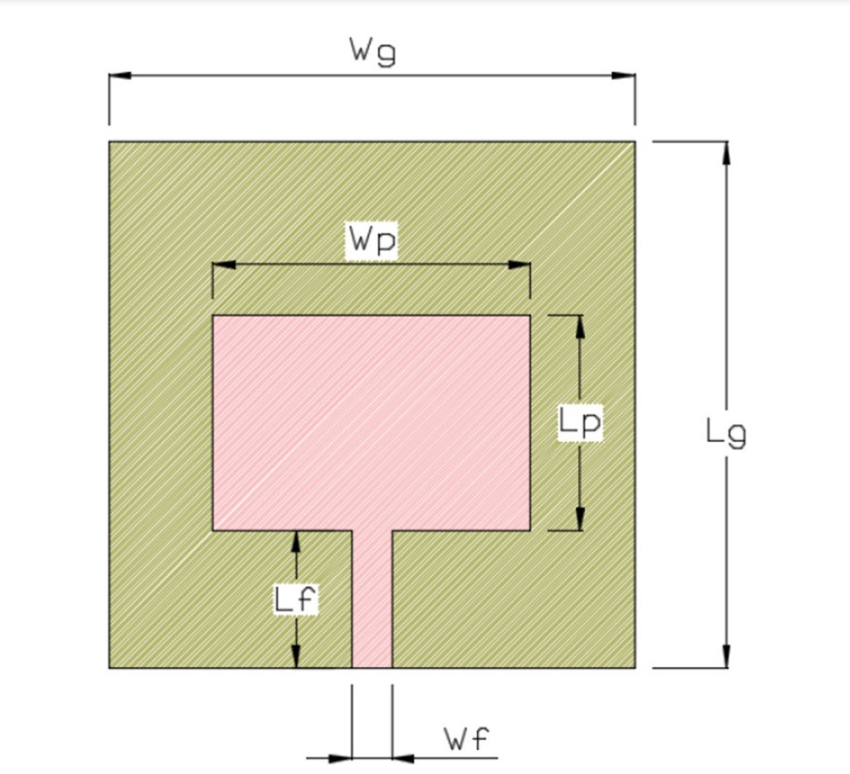
Figure 3.1.1: 2D design for the single element MPA
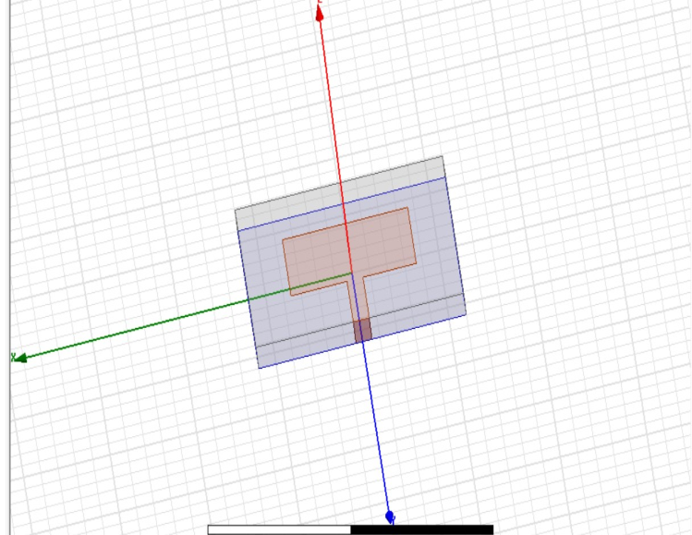
Figure 3.1.2: 3D design for the single element MPA
Width of the patch:
The width of the patch is calculated by utilizing the below equation,
$$Wp=\frac{c}{2fr\sqrt{\frac{Er+1}{2}}}$$
Here, Wp is representing the width of the patch, c is representing the speed of light which has the value of 3 108, the resonance frequency is denoted as f r,and"r is representing the dielectric constant value.
Figure 3.1.3: S11 parameter.
Figure 3.1.4: Gain parameter

3.2 Task 2:
Creating a design of MIMO (Multiple Input and Multiple Output) microstrip patch antenna array design in HFSS for frequency(f)=, display all the resulting parameters.
SL.no | Design parameters | Description | Obtained values | Optimized values
1 | Wp | Width of patch | 3.386 | 3.62
2 | Lp | Length of patch | 2.551 | 2.45
3 | Wg | Width of substrate and ground plane | 5.49 | 6
4 | Lg | Length of substrate and ground plane | 4.65 | 6
5 | Wf | Width of feed line | 0.46 | 0.46
6 | Lf | Length of feed line | 1.57 | 1.57

TABLE3.2.1: Obtained and optimized values of design parameters
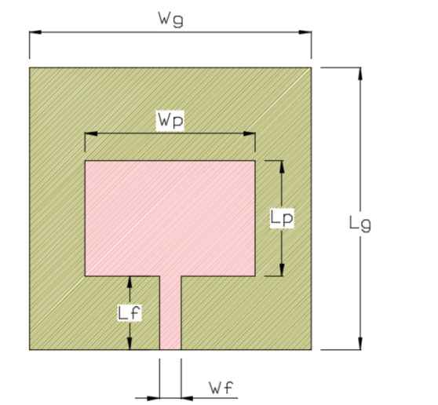
Figure3.2.1: 2D design for the single element MPA
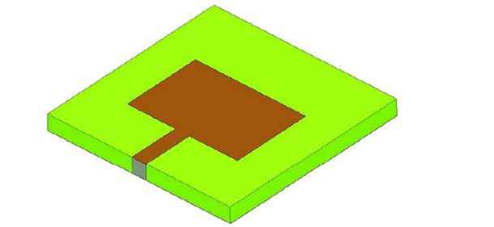
Figure 3.2.2: 3D design for the single element MPA
Width of the patch:
The width of the patch is calculated by utilizing the below equation,
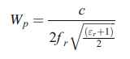
Here, Wp is representing the width of the patch, c is representing the speed of light which has the value of 3108, the resonance frequency is denoted as f r, and "r is representing the dielectric constant value.
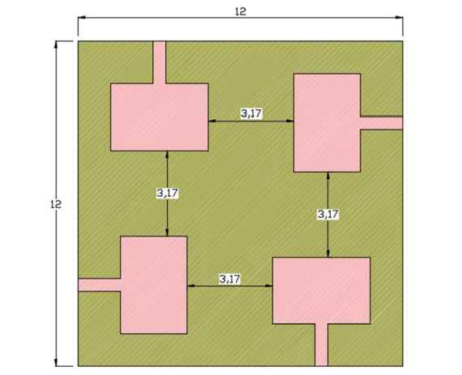
Figure 3.2.3: 2D design for the proposed circular array MPA
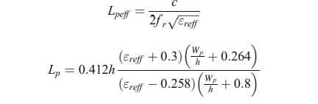
Where, h is representing the thickness of the substrate, the effective dielectric constant is denoted as "reff and it is calculated by utilizing the below equation,
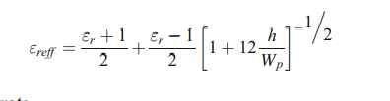
Length of the substrate The length of the substrate is estimated by implementing the following equation,
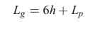
Where, the length of the substrate is denoted as Lg.
Design and analysis of MPA
This section performing the design and analysis for the three various types microstrip patch antenna (MPA) such as Single element MPA, 2 × 2 rectangular array based MPA, and circular array based MPA. Here, the circular array based MPA is proposed for the 5G wireless communication. The whole design analysis process is conducted in High-Frequency Structure Simulation (HFSS) which is the platform of ANSYS software. The designed antennas are validated by attaining the parameters such as Gain, Return loss, Mutual coupling, VSWR, and Bandwidth. These parameters values of three MPA design are compared to find the efficient antenna for the 5G wireless communication. The substrate material and its thickness are already discussed in Section 3 which applied for the all three MPA designs. The copper material with 0.0175 mm is utilized for the patch and ground plane. The resonance frequency for these three-antenna design is taken as 35 GHz which best for the 5G wireless communication.

Design of single element MPA
In this section, the single element microstrip patch antenna is design and validated by attaining the validation parameters such as Gain, return loss, mutual coupling, VSWR, and bandwidth. Single element antenna contains single patch and single feed line which are utilized as the transmitter or receiver. The S parameters of the single element Micro Strip Antenna
Figure3.2.4 :S parameters of single element in micro strip antenna

Figure3.2.5: Gain of single element in micro strip antenna

Design of proposed circular array MPA
This section is describing the details about designing methods for the proposed circular array MPA and its analysis results. Here, also the same designing parameters are used which are already utilized for the single element MPA and 2 × 2 rectangular array MPA. It also has the four patches, four feed lines, and four ports. Here, the dimensions of the substrate and the ground is remaining similar as 2 × 2 rectangular array. The radiation box of the proposed circular array MPA design is same as 2 × 2 rectangular array MPA. The patches are located as shown and the 3D view of the proposed circular array MPA is shown. The design of circular array structure is located over the substrate as shown in Fig. 5. The steps which are utilized for designing the 2 × 2 rectangular array MPA are utilized for designing the proposed circular array MPA.

Figure 3.2.6: S parameter of circularized array micro strip array

Figure 3.2.7: of circularized array micro strip array

3.3 Task 3
Creating a design of Circularly polarized parasitic strips for frequency(f)= in HFSS, display all the resulting parameter.
Parameters | Values | Parameters | Values
L1 | 17.8 | L9 | 6
L2 | 23 | Ls | 55
L3 | 4.5 | W | 3
L4 | 17 | W1 | 2
L5 | 9 | Ws | 50
L6 | 17.8 | Wg | 20
L7 | 6 | D | 1
L8 & Wf | 26 & 0.7 | H | 0.8

Table 3.3.1: Parameters and their respective Values for design
Variation in Length of Feed Line (L8)
To bring out the suitable value for L8 (length of the feed) parametric study is conducted and shows that the |S11| and the axial ratio are sensitive to the variations of L8, When L8 = 24 mm the bandwidth of 3 GHz (2–5 GHz) and ARBW of 1.1 GHz (2–3.1 GHz) is observed but it is not optimum in terms of return loss. For L8 = 26 mm, a single wideband of 3.4 GHz (2–5.4 GHz) and ARBW of2.5 GHz (2.9–5.4 GHz) is obtained. When L8 = 28 mm, Parametric analysis of the proposed antenna by varying length of the feed, L8 in terms of |S11| bandwidth of 3 GHz (2.4–5.4 GHz) and ARBW 1.1 GHz (2–3.1 GHz) is observed, again which is not optimum in terms of impedance bandwidth. Therefore, from the stepwise analysis, it is suggested that the best-suited value for L8 is 26 mm.
Variation in Strip Width (W)
The stepwise growth of the dimension of strip width (W) is investigated and corresponding results are presented Under the investigation, it is observed Strip Width, W in terms of |S11| that for W = 2 mm two narrow resonating bands of 2–2.4 GHz, and 4.8–5.2 GHz with ARBW of 200 MHz (3.5–3.7 GHz) are obtained. For W = 3 mm, a single wideband of 3.4 GHz (2–5.4 GHz) and ARBW of 2.5 GHz (2.9–5.4 GHz) is obtained. Further increment in the width (W = 4 mm) leads to dual resonance with less 3-dB ARBW of 300 MHz (4.8–5.1 GHz). Consequently, from the perusal of the above investigation, it is observed that W = 3 mm is the optimum width size to achieve the maximum throughput for the proposed antenna.
Variation in the Gap Between the Parasitic Strips (D)
To enhance the impedance bandwidth of the proposed configurations parametric analysis is carried out in terms of the gap between the parasitic strips (D). Axial ratio variation is also observed. From the perusal it is noted that for D = 1.5 mm and D = 2 mm only one lower frequency band is identified and there is no 3-dB ARBW for D = 1.5 mm and a narrow 3-dB ARBW of 3–4.1 GHz for D = 2 mm. The maximum impedance bandwidth and 3-dB ARBW are achieved for D = 1 mm. Parametric analysis of the proposed antenna by varying the gap between the parasitic strips, D in terms of |S11|which is finalized as the optimum gap between the parasitic strips.
DESIGNING STEPS OF THE ANTENNA:
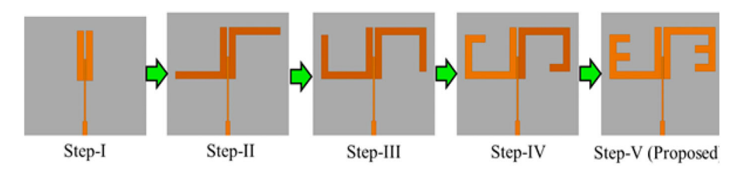
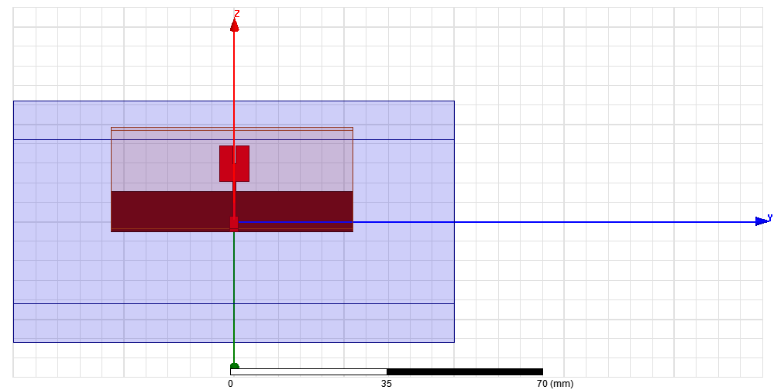
STEP1:
Figure 3.3.1: design of an antenna Figure 3.3.2: S parameters of an antenna
STEP2:
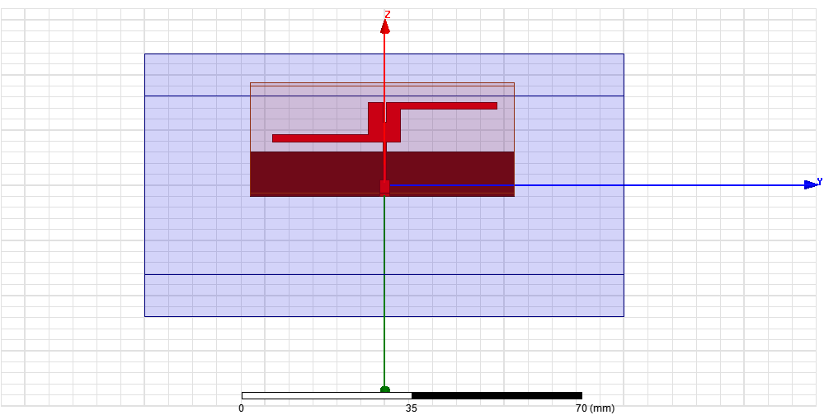
Figure 3.3.3: design of an antenna Figure 3.3.4: S parameters of an antenna
STEP3:
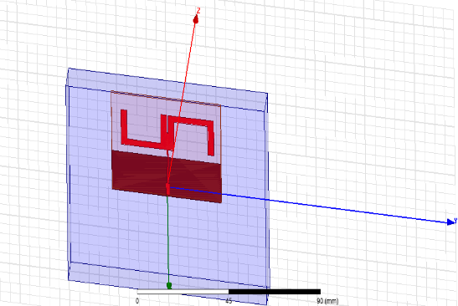
Figure 3.3.5: design of an antenna Figure 3.3.6: S parameters of an antenna
STEP4:
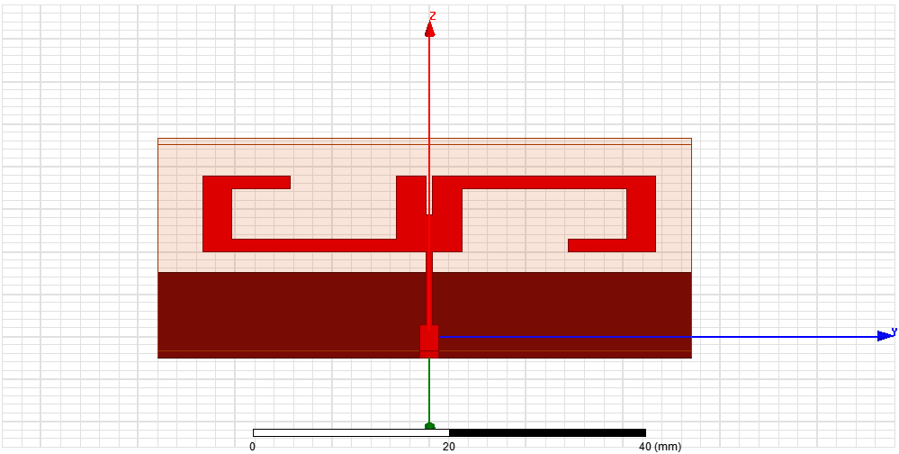

Figure 3.3.7: design of an antenna Figure 3.3.8: S parameters of an antenna

STEP5:
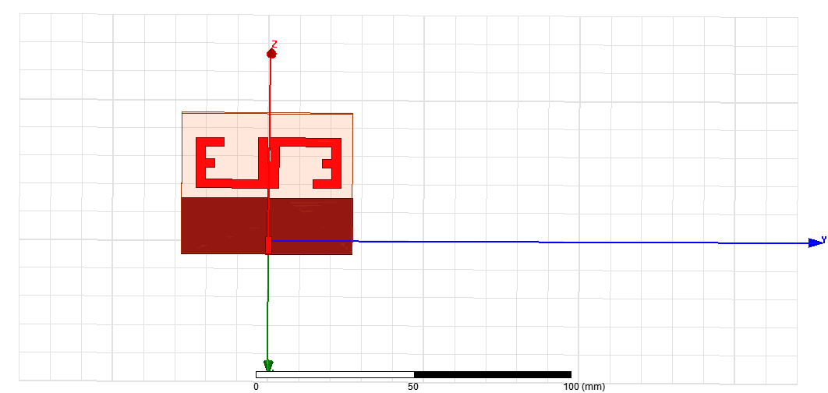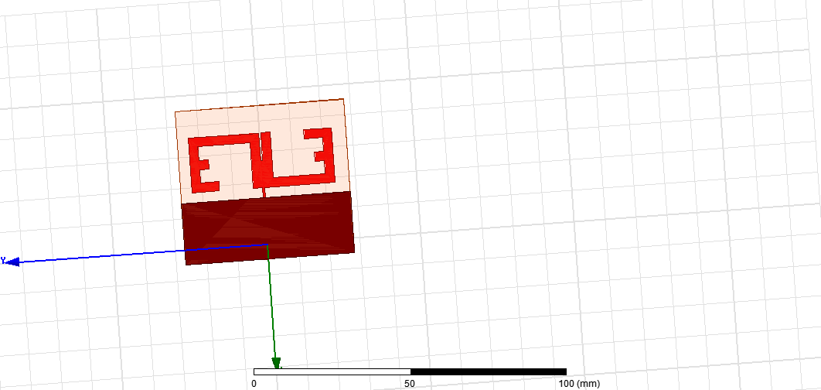
Figure 3.3.9: Front view of an antenna Figure 3.3.10: Back view of an antenna

Figure 3.3.11:S parameter of an antenna Figure 3.3.12: Gain of an antenna

Figure 3.3.13: Electric field of an antenna Figure 3.3.14: Magnetic field of an antenna

CONCLUSION
In conclusion, this internship provided an opportunity to explore various image processing techniques and designing of various antennas. In this of image processing, accurate segmentation of foreground and background regions remains a fundamental challenge. The utilization of thresholding techniques, both singular and double gives us the fundamental approach. Additionally, the application of morphological operations enhanced image quality by filling cavities, smoothing borders, and eliminating noise. Furthermore, Image analysis tasks such as object detection and counting, are fundamental in various domains, including medical imaging, surveillance, and computer vision. The construction of a confusion matrix allowed us to the algorithm's accuracy and correctness. Overall, this internship has enriched our knowledge and practical skills.
Image processing is a versatile field with a wide range of applications and goals, making it a crucial component of various industries and technologies. One prominent application is in the field of medical imaging, where image processing techniques are used to enhance and analyse medical images, aiding in the diagnosis and treatment of diseases. Another vital area is in computer vision, where image processing enables machines to interpret and understand visual data, enabling tasks like object recognition, autonomous navigation, and facial recognition.
As we designed so many antennas that are depend upon required parameters and their usage. In today's world, antennas are used in various applications, including wireless communication (cell phones, Wi-Fi), TV and radio broadcasting, radar systems, GPS navigation, satellite communication, IoT devices, aerospace, aviation, military and defense, medical devices, wireless charging, smart homes, scientific research, maritime and navigation, and automotive technologies. They enable data transmission, signal reception, and connectivity in a wide range of devices and systems, making them an integral part of modern technology and communication.

REFERENCES
[1] MATLAB documentation. https://in.mathworks.com/help/images
[2] GNU Octave (version 8.3.0) documentation https://docs.octave.org/latest
[3] https://www.researchgate.net/publication/271770488_A_Review_on_Image_Processing
[4] https://jivp-eurasipjournals.springeropen.com/articles/10.1186/s13640-018-0383-6
[5] https://www.viva-technology.org/New/IJRI/2018/10.pdf
[6] https://www.simplilearn.com/image-processing-article
[7]https://medium.com/analytics-vidhya/how-to-create-a-confusion-matrix-with-the-test-result-in- your- training-model-802b1315d8ee
[8] https://in.mathworks.com/help/images/morphological-filtering.html
[9] https://datagen.tech/guides/image-annotation/image-segmentation/
[10] https://www.v7labs.com/blog/image-processing-guide
[11] https://doi.org/10.1007/s11042-023-14628-2
[12] https://doi.org/10.1080/03772063.2023.2183905
[13]https://en.wikipedia.org/wiki/Antenna_measurement#:~:text=Typical%20parameters%20of%20antennas%20are, antenna%20in%20a%20given%20direction.
[14].https://jemengineering.com/blog-intro-to-antenna polarization/#:~:text=Circular%20polarization%20helps%20mitigate%20the,particularly%20effctive%20performance%20and%20gain.
[15] https://antennatestlab.com/wp-content/uploads/2017/09/CP-Explained-Without-Math.pdf [16]https://cdn.thomasnet.com/ccp/10014548/223252.pdf

APPENDIX

This section presents the implementation of algorithms discussed in relation to our problem statements, with the code in Octave.
Problem statement-1:
Classify the foreground and background regions in an image through implementation of a singular thresholding technique.
CODE:
clc
clearvars
close all
pkg load image
load p44.mat
load ground_truth_p44.mat
gimg=rgb2gray(img);
tic;
thresh = 1:1:254;
for k= 1:length(thresh) disp(k)
I_bin{k} = gimg < thresh(k); endfor
for k = 1:length(thresh)
TP(k) = nnz(A==1 & I_bin{k}==1);
FP(k) = nnz(A==0 & I_bin{k}==1);
TN(k) = nnz(A==0 & I_bin{k}==0);
FN(k) = nnz(A==1 & I_bin{k}==0);
Accuracy(k) = (TP(k)+TN(k))/(TP(k)+TN(k)+FP(k)+FN(k));
TPrate(k) = TP(k)/(TP(k)+FN(k));
FPrate(k) = FP(k)/(FP(k)+TN(k));
endfor
time = toc;
best_valu = max(Accuracy);
best_img = find(Accuracy == max(Accuracy));
figure
imshowpair(img,A,'montage')
title("Actual image and ground truth",'FontSize',20);
figure
imshow(I_bin{best_img})
title("best SINGLE threshold image"); figure
plot(FPrate, TPrate)
title("ROC for 1 threshold",'FontSize',30);
xlabel('FPrate');
ylabel('TPrate');

Problem statement-2:
Classify foreground and background regions within an image through the implementation of a double thresholding technique.
CODE:
clc
clearvars
close all
pkg load image
load p44.mat
load ground_truth_p44.mat
lod_data=load('data.txt');
r_cmp=img(:,:,1);
g_cmp=img(:,:,2);
b_cmp=img(:,:,3);
thresh1 = 91:1:95;
thresh2 = 80:1:85; tic;
for i = 1:length(thresh1)
disp(i)
for j = 1:length(thresh2)
I_bin1{i,j} = (r_cmp < thresh1(i)) | (g_cmp < thresh2(j));
[Accuracy{i,j},tp_rate(i,j),fp_rate(i,j)] = Accuracy_cal_func (I_bin1{i,j},A);
endfor
endfor
time1 = toc;
best = cell2mat(Accuracy);
best_red = max(best,[],2);
best_green= max(best,[],1);
best_red_Acc = max(best_red)
best_green_Acc = max(best_green)
best_red_img = find(best_red == max(best_red))
best_green_img = find(best_green == max(best_green))
figure
imshowpair(I_bin1{best_red_img,best_green_img},A,'montage')
figure
hold on;
plot(fp_rate(best_red_img,:),tp_rate(best_red_img,:),'r')
plot(lod_data.data{1,1},lod_data.data{1,2},'b')
xlabel('False Alarm Rate','FontSize',20);
ylabel('True Detection Rate','FontSize',20);
title(" ROC plot for single and double thresholds.(red-single,blue-double)",'FontSize',16);
hold off;
User defined function:
function [Accuracy,TPrate,FPrate] = Accuracy_cal_func(I_bin,A)
TP = nnz(A==1 & I_bin==1);
FP = nnz(A==0 & I_bin==1);
TN = nnz(A==0 & I_bin==0);
FN = nnz(A==1 & I_bin==0);
Accuracy = (TP+TN)/(TP+TN+FP+FN);
TPrate = TP/(TP+FN);
FPrate = FP/(FP+TN);
End

Problem statement-3:
Apply the morphological operations to a given binary image, to fill cavities within the regions of interest, to attain smooth borders and to eliminate noise, thereby enhancing the quality of the image.
CODE:
clc
clearvars
close all
load ground_truth_p44.mat
pkg load image
org_img = imread('C:\octave\2nd_thresh.jpg');
resize = imresize(org_img,[size(A)]);
se=strel('square',25);
morph=imclose(resize,se);
morp_img=imopen(morph,se);
figure
imshow(A) figure
imshow(morp_img)
figure
imshow(org_img)
[Accuracy,TPrate,FPrate] = Accuracy_cal_func (morp_img,A)
fprintf('Accuracy of morphed image compared to ground truth is %f',Accuracy)

Problem statement-4:
Determine the accurate and optimal thresholds for generating a binary mask for a given RGB image after converting it into its HSV equivalent.
CODE:
clc
clearvars
close all
pkg load image
load ground_truth_p44.mat
load p44.mat
imgg = rgb2hsv(img);
h_comp = imgg(:,:,1);
s_comp = imgg(:,:,2);
v_comp = imgg(:,:,3);
thresh1 = 0:0.01:1;
thresh2 = 0:0.01:1; tic;
for i = 1:length(thresh1)
disp(i)
for j = 1:length(thresh2)
I_bin1{i,j} = (h_comp > thresh1(i)) | (s_comp > thresh2(j));
[Accuracy{i,j},tp_rate(i,j),fp_rate(i,j)] = Assn4_a_final_results(I_bin1{i,j},A);
endfor
endfor
best = cell2mat(Accuracy); best_hue = max(best,[],2);
best_sat= max(best,[],1);
best_hue_Acc = max(best_hue);
best_sat_Acc = max(best_sat);
best_hue_img = find(best_hue == max(best_hue))
best_sat_img = find(best_sat == max(best_sat))
%imshowpair(A,I_bin1{best_red_img,best_green_img},'montage')
mask = I_bin1{best_hue_img,best_sat_img};
fprintf('Accuracy of mask compared to ground truth is %f',best_hue_Acc)
fprintf('best threshold for hue channel is %f.',best_hue_img-1)
fprintf('best threshold for saturation channel is %f.',best_sat_img-1)
figure
imshow(mask)

Problem statement-5:
For the given database of 51 images, Identify and count the number of balloons present in each image. Construct a confusion matrix that which gives the accuracy.
CODE:
clc
clearvars
close all
pkg load image
mat = dir('database_1/*.mat');
for i=1:51
disp(i)
file_name = fullfile('database_1',mat(i).name);
load(file_name)
imgg=rgb2hsv(img);
h_comp = imgg(:,:,1);
s_comp = imgg(:,:,2);
mask=[h_comp > 0.2100 | s_comp > 0.4800];
sc=strel('disk',7,0);
output_img=imopen(mask,sc);
se=strel('disk',4,0);
output_img=imclose(output_img,se);
im_out=bwareaopen(output_img,50,4);
cc=bwconncomp(im_out,4);
numb = cc.NumObjects;
list(i)=numb;
imshowpair(img,output_img,'montage')
title(["Number of balloons : ",num2str(cc.NumObjects)],'FontSize',25);
pause(1);
endfor
true_class = [0 1 1 1 1 1 1 0 1 1 1 1 1 1 1 1 1 1 1 1 1 1 1 1 1 1 1 0 2 1 2 2 2 2 2 1 1 1 2 2 2 1 1 2 2 2 3 3
3 2 2];
predicted_class = list;
Con_mat=confusionmat(true_class,predicted_class);
labels = {'0 balloons', '1 balloons', '2 balloons', '3 balloons'};
con_chart = confusionchart(Con_mat,labels);
con_chart.Title = "NUMBER OF BALLOONS";
FontSize=50;

